**CAO Assignment Prashanth.S (19MID0020)**

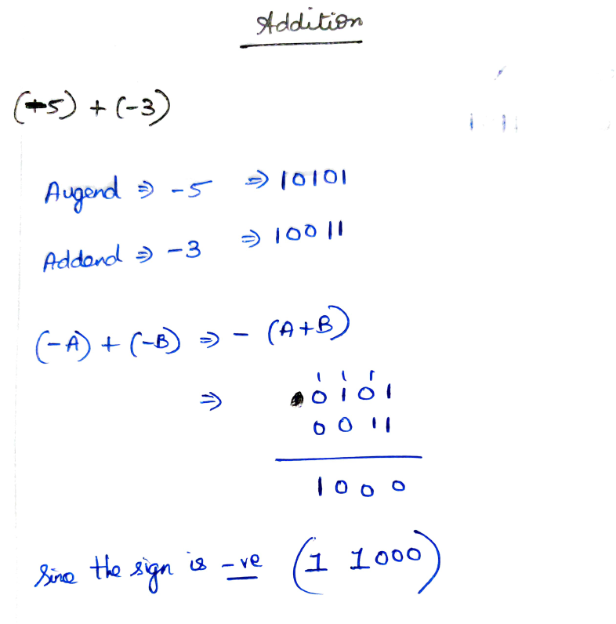

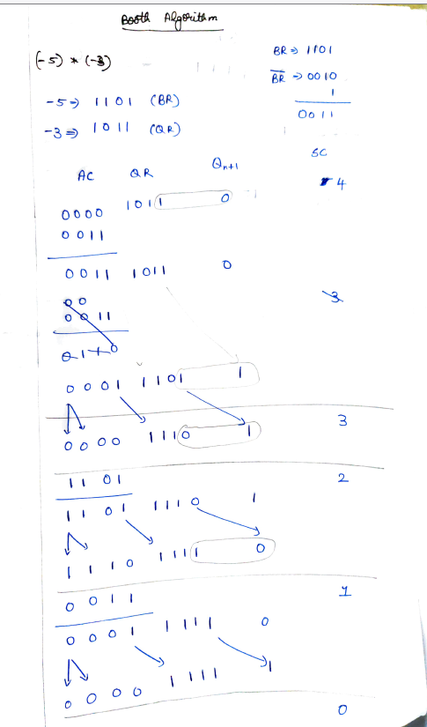

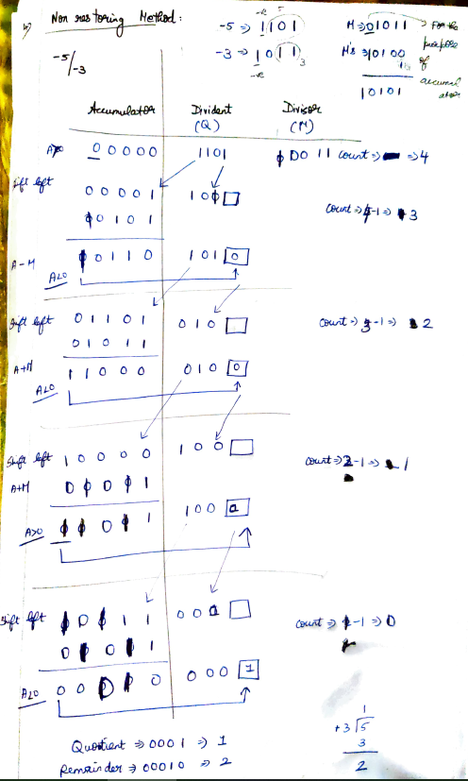

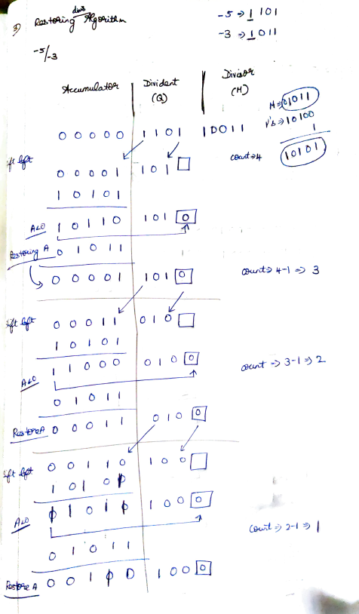

**My PC specification:**

Model - HP 14ce1001tx

Processor - Intel® core(tm) i5-8265u cpu @ 2.30ghz (14 nm Processor)

Ram - 16 gb (LPDDR 4 2133)

internal - 500 gb 🡪 ssd

1 tb 🡪 hdd

Type: - 64-bit processor

OS - Windows 10 Home Single Language

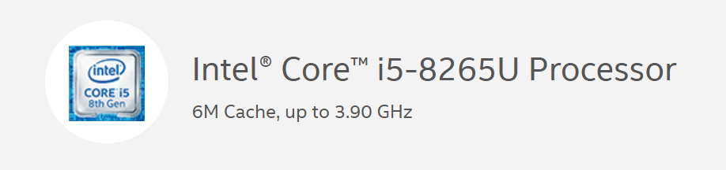

**Performance Specifications**

|  |  |
| --- | --- |
| Number of Cores | 4 |
| Number of Threads | 8 |
| Processor Base Frequency | 1.60 GHz |
| Max Turbo Frequency | 3.90 GHz |
| Cache | 6 MB Intel® Smart Cache |
| Bus Speed | 4 GT/s |
| Intel® Turbo Boost Technology 2.0 Frequency‡ | 3.90 GHz |
| TDP | 15 W |
| Configurable TDP-up Frequency | 1.80 GHz |
| Configurable TDP-up | 25 W |
| Configurable TDP-down Frequency | 800 MHz |
| Configurable TDP-down | 10 W |

**Memory Specifications**

|  |  |
| --- | --- |
| Max Memory Size (dependent on memory type) | 64 GB |
| Memory Types | DDR4-2400, LPDDR3-2133 |
| Max # of Memory Channels | 2 |
| Max Memory Bandwidth | 37.5 GB/s |
| ECC Memory Supported ‡ | No |

**CPU Utilization**

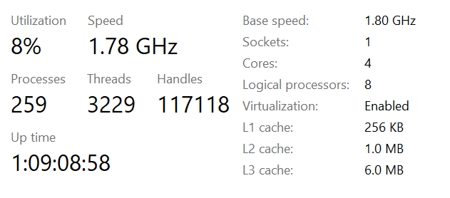

**Memory Specification**

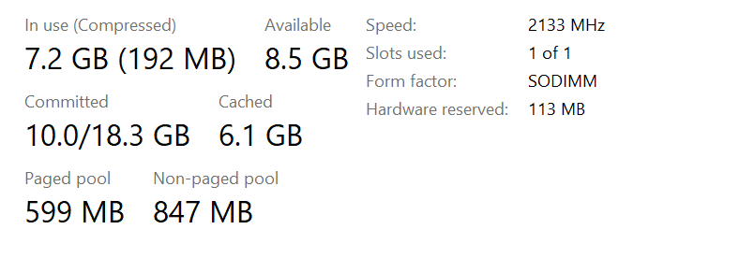

**SSD Specification**  
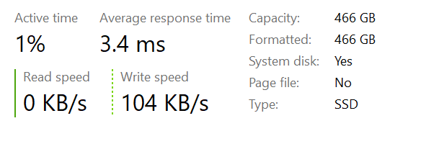

**HDD Specification**  
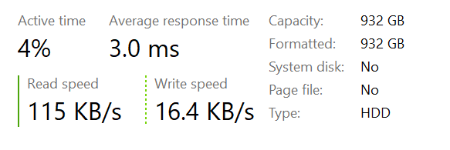

**b) Instruction**

1)My Processor is compactible with 64 bit instruction set.

2)An instruction set refers to the basic set of commands and instructions that a

microprocessor understands and can carry out.

3)My processor uses x86_64-bit architecture.

Basically my processor supports following types of instructions (x86_instruction):

4)Data Transfer Instructions

5)Arithmetic Instructions

6)Bit Manipulation Instructions

7)Program Execution Transfer Instructions (Branch & Loop Instructions)

8)Processor Control Instructions

9)Iteration Control Instructions

10)Interrupt Instructions

11)Instruction Set Extensions are additional instructions which can increase

performance when the same operations are performed on multiple data

objects. These can include SSE (Streaming SIMD Extensions) and AVX (Advanced Vector Extensions).

12) String Instructions

**c).Arithmetic Instructions (of x86 instruction set)**

These instructions are used to perform arithmetic operations like addition, subtraction, multiplication, division, etc.

Following is the list of instructions under this group –

Instructions to perform addition

1)ADD − Used to add the provided byte to byte/word to word.

2)ADC − Used to add with carry.

3)INC − Used to increment the provided byte/word by 1.

4)AAA − Used to adjust ASCII after addition.

5)DAA − Used to adjust the decimal after the addition/subtraction operation.

Instructions to perform subtraction

6) SUB − Used to subtract the byte from byte/word from word.

7) SBB − Used to perform subtraction with borrow.

8) DEC − Used to decrement the provided byte/word by 1.

9) NPG − Used to negate each bit of the provided byte/word and add 1/2’s complement.

10) CMP − Used to compare 2 provided byte/word.

11) AAS − Used to adjust ASCII codes after subtraction.

12) DAS − Used to adjust decimal after subtraction.

Instruction to perform multiplication

13) MUL − Used to multiply unsigned byte by byte/word by word.

14) IMUL − Used to multiply signed byte by byte/word by word.

15) AAM − Used to adjust ASCII codes after multiplication.

Instructions to perform division

16) DIV − Used to divide the unsigned word by byte or unsigned double word by word.

17) IDIV − Used to divide the signed word by byte or signed double word by word.

18) AAD − Used to adjust ASCII codes after division.

19) CBW − Used to fill the upper byte of the word with the copies of sign bit of the lower byte.

20) CWD − Used to fill the upper word of the double word with the sign bit of the lower